Overview
20 containers with samples, 18 with cattle-slurry, 2 ammonium carbonate standards
9 with packed soil, 9 with soil collected on field experiment day with surface preserved
3 types of treatments, H₂SO₄, acetic acid and no acid (untreated)

Sample Naming Convention
Field soils = F
Packed soils = P

H₂SO₄ treatment = H₂SO₄
Acetic acid treatment = AA
No treatment = U

Number relates to container/jar
Ie. Sample in container 18 will be described as 18.F.AA

Experimental Setup
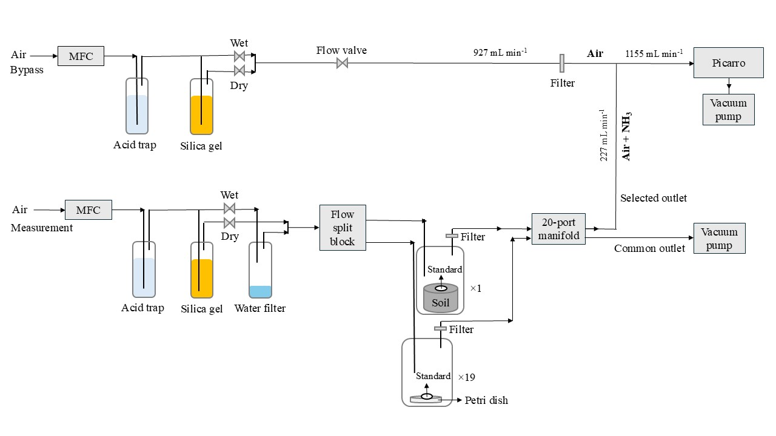

Day -2 Dry Agro soil
…

Day -1: Prepare samples, cattle slurry, analysis and setup
Tasks are in prioritized order
Samples: F needs to be collected, P needs to be packed, STD prepare solution
Slurry: Collect and acidify H₂SO₄ and AA + untreated. Check pH before and after!
Analysis: field-soil water content analysis, slurry TAN analysis, slurry DM analysis, STD ammonia content analysis.
Setup: check flows, prepare acid-trap, test Picarro-cycle, change Any desk code

Collect cattle slurry and soil-samples, test soil water content
Remember to calibrate the pH meter
Collect cattle slurry
- Stored in building close to L30 (G31?)
- Grap a large bucketful, will be weighed in the lab $≈$ 1.5-2 L
Collect soil samples
- Building connected to main Foulum building PV24?
- Cellar
- Cooling room number X?
- Reol 8 kasse 139
- From cattle experiment - 2025-10-28
Test of F-soil water content
- L32
- Weigh 3 aluminum containers, weigh soil from 3 F-samples in container, put into oven.
- Meanwhile, check whether the red lids can be easily removed without spilling soil
- Take out of oven and weigh again after 24 h.

Slurry acidification:
500 g of slurry per treatment
- Check pH beforehand and afterwards, as triplicates
H₂SO₄
Using same weight as large-scale will require 0.79 mL 95% wt. H₂SO₄ (check detailed calculations)
All added at once. Or over time $100 μL$ (except last addition) each time with 1-minute intervals between addition
AA
$100 μL$ each time, wait for 1 minute and measure pH, until similar to H₂SO₄ slurry.
Storage
- 100 mL of each for long-term storage
- Rest, use for analysis same day, when done store in closed container in cooler or outside if there is no risk of frost.

Slurry TAN and DM analysis
As triplicates for each slurry treatment?
- Coordinate with Janni in the interval 11:00-14:00

Field soil preparation
- Choose 9 samples, mark the sides, remove the top and film them. Leave them for next day - cooler or simply on the lab table clearly marked

Packed soil preparation
- Collect soil from outside storage at Biogas-plant
- Sieve the soil by removing stones and similar - allows the clumps of soil. Mix afterwards.
- Mark a soil for scratching the surface 2 mm
- 37.5 g soil per packing (150 g in total)
- Add XXX mili-Q water to mimic field conditions

Packing procedure
- Weigh the soil and pack it (use the right stamp, smallest to largest!)
- Scratch the soil evenly
- Add water
- Repeat 4 times

Storage
- Mark and film the samples
- Store in cooler or lab table, clearly marked

Standard preparation
- 2.27 ammonium carbonate (NH₄HCO₃) and 20 g potato starch, 100 mL milli-Q water
- Dissolved starch in 60 $℃$ sufficient milli-Q water
- At room temperature, add the ammonium carbonate, adjust volume to 100 mL
- Measure exact nitrogen content [g_{N} / L] using ammonium test kit
- Store in cooler.

Setup preparation
- Start the pump Tune flows to 0.225 L/min
- Set up valve-cycles and test the changes.
- Change Any Desk password to windtunnel
Acid trap:
2.5 L total
0.05 M H₂SO₄, use approx. 6.85 mL

Soil analysis
Do only one test, don’t want to sacrifice more soil-samples than necessary
Can also be done the next day if time is short
- 20 g soil
- 20 mL dem. Water
- Shake tube
- Centrifuge for 12 min, 4200 RPM - remember counterweight
- Measure pH of supernatant (liquid fraction)

Day 1: Start of the experiment

Setup tests and slurry assessment before starting
- Ensure all sample-flows are 0.225 L/min, before experimental start
- Ensure valve-shifts work as intended
- Note time-delay between picaro and actual time
- Measure pH of slurries as triplicates

Start the experiment, prepare current sample
Approx 2-3 min before valve shift, remove plastic-wrap from current sample
Add 2 g of needed slurry as drops, in small as droplets
Exchange red plastic lid, with petri-dish
Add to Picarro setup
Note picaro-time for the shift, and the flow of the sample stream, and bypass

Day: 2-6: Extract data via Any desk
Download yesterday’s raw Picarro file into own folder via Any Desk
Repeat for next day

Day 7: End of the experiment
Note Picarro-time for the end of the experiment.
Download raw Picarro file for the final day.
Note bypass and sample flows, is expected to have a slight decrease - an average between start and end will be used.
Remove the samples from the setup, can most likely dilute and put into sink.

Calculation details

Slurry acidification:
Amount of H₂SO₄
$$\frac{0.18 kg_{acid}}{60.05·{10}^{-3} t_{slurry}}=\frac{2.99·kg_{acid}}{t_{slurry}}$$
If using 500 g in lab:
$$m\left(H_{2}SO_{4}\right)= 0.500 kg_{slurry}·{10}^{-3}\frac{t_{slurry}}{kg_{slurry}}·2.99\frac{kg_{acid}}{t_{slurry}}=0.001495·kg_{acid}·{10}^{3}=1.495 g$$
$$ρ\left(H_{2}SO_{4} 95 \%wt\right)=1.8837\frac{g}{mL}$$
$$V=\frac{m}{ρ}=\frac{1.495 g}{1.8837\frac{g}{mL}}=0.79·mL$$

Packed soils
Amount of soil to use:
Bulk density of soil during the field experiment: $1.50\frac{g}{cm^{3}}±0.09\frac{g}{cm^{3}}$
$$V_{sample}=100 cm^{3}$$
$$m_{soil, sample}=100 cm^{3}\left(1.50\frac{g}{cm^{3}}±0.09\frac{g}{cm^{3}}\right)=150 g±9 g$$
$$m_{soil, pack}=\frac{150 g±9 g}{4}=37.5±2.25$$
Amount of water to add
Field gravimetric water content:
$$U_{field, cattle, dry}=\frac{m_{water}}{m_{soil}}= 0.17\frac{g_{water}}{g_{soil}}$$

Agro soil has 15.5 % water content calculated on a “wet” basis
$$U_{ agro, wet}=\frac{m_{water}}{\left(m_{soil}+m_{water}\right)}=0.155$$
$$U_{agro,dry}=\frac{0.155}{\left(1-0.155\right)}=0.183$$
Conversion - redefine mass of water:
$$U_{wet}\left(m_{soil}+m_{water}\right)=m_{water}$$
$$U_{wet}m_{soil}+U_{water}m_{water}=m_{water}$$
$$U_{wet}m_{soil}=m_{water}-U_{wet}m_{water}$$
$$U_{wet}m_{soil}=m_{water}(1-U_{wet)}$$
$$\frac{U_{wet}m_{soil}}{(1-U_{wet)}}$$
Insert into Dry definition
$$U_{dry}=\frac{m_{water}}{m_{soil}}=\frac{\left(\frac{U_{water}m_{soil}}{1-U_{water}}\right)}{m_{soil}}=\frac{U_{water}}{(1-U_{water})}$$

Setup - Acid trap
$$C_{1}V_{1}=C_{2}V_{2}$$
$$C_{2}=0.05 M$$
$$V_{2}=V_{water}+V_{1}=2.5 L$$

If using is 95 %Wt. H₂SO₄:
$$ρ_{solution}=1.88337 g mL^{-1}$$
For 1000 mL
$$m_{solution}=1883.37 g$$
$$m_{H2SO4}=1883 g·0.95=1789.20 g$$
$$n_{H2SO4 }=\frac{1789.20 g}{98.079 g mol^{-1}}=18.24\frac{mol}{L}=C_{1}$$
$$V_{1}=\frac{C_{2}V_{2}}{C_{1}}=\frac{0.05 M·2.5 L}{18.24 M}·{10}^{3}\frac{mL}{L}=6.85307·mL$$
$$V_{water}=2500 mL-6.85307·mL=2493.15·mL$$

